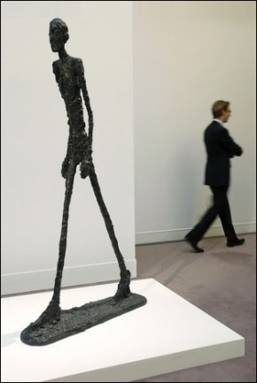

Giacometti***, Walking Man***

at 2010 Sotheby Auction

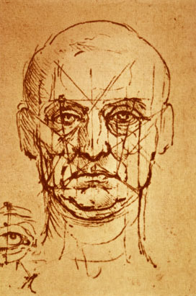

Leonardo, *Proportions   
 of the Face (*1498)

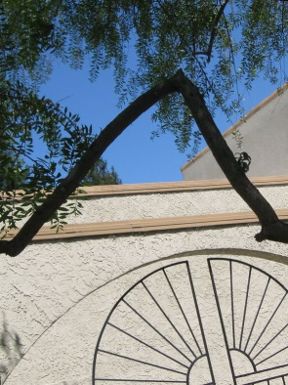

Pepper tree Λ-branch

Montebello Avenue

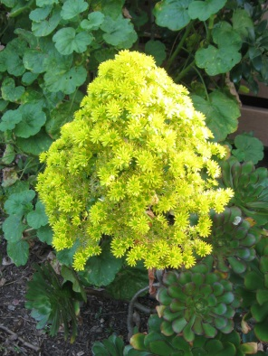

Houseleek, Paulson Park

(*Aeonium arboretum*)

**Seeing the Soul Everywhere**

It began with the *Walking Man—*

Giacometti’s sculpture showing  
the Platonic Lambda Λ (*Timaeus 35b*)­—

“Soul of the Universe” manifesting

itself whenever we’re walking­—

then again in Leonardo’s sketch

of the nose at the center of our   
face whenever we’re breathing.

Now the soul greets me in the branch

of the Pepper tree down the street  
and the Houseleek in my courtyard

and the Butterfly Bush nearby.

I recall Gerard David’s painting

of *Cupid & Psyche* with butterfly  
over her head— for in Greek, both

Psyche and butterfly means “soul”.

Crossing Rengstorff at Stanford Ave,

I see more lambda-shapes Λ in

the arrowhead sign of bike trails,

the pine cones scattered around,

on top of Pine trees and Redwoods

as well as V-shape of flying geese.  
The sacred is no longer hidden—

I’m seeing the soul everywhere

for it’s the soul that creates us,

sustains us and nourishes us—  
the origin of all things—

Blessings from the soul, blessings for all.

Peter Y. Chou

Mountain View, 8-21-2017

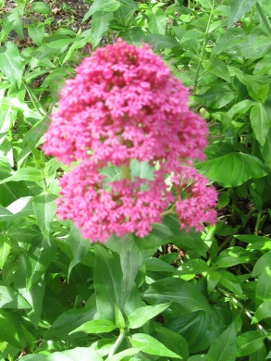

Butterfly Bush

(*Buddleia davidii*)

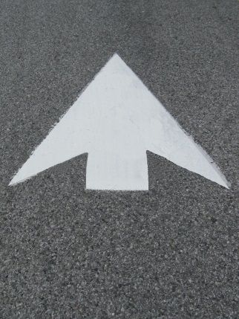

Arrowhead Sign, Bike Lane

Rengstorff Ave, Mountain View

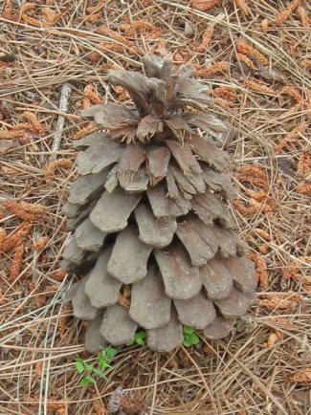

Pine Cone, Rengstorff Ave &  
 Stanford Ave , Mountain View

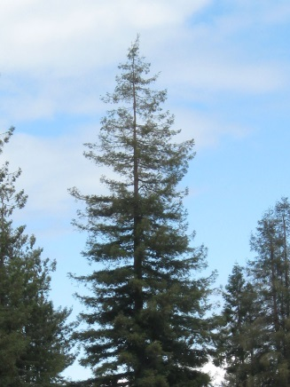

Lambda Λ-shape on top   
 of Redwood Tree across

Hackett Ave, Mountain View

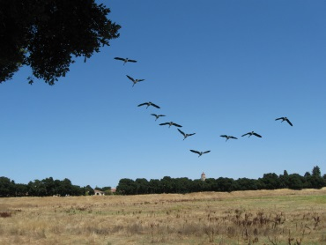

Flight of Geese in V-formation

Lake Lagunita, Stanford Univeristy