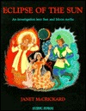

Janet McCrickard***,   
 Eclipse of the Sun*** (1990)

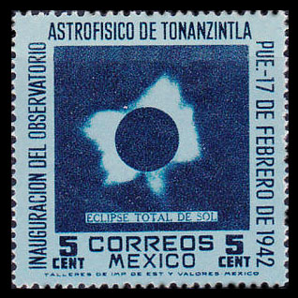

Mexico #775, 5 centavos

(issued Feb. 17, 1942)

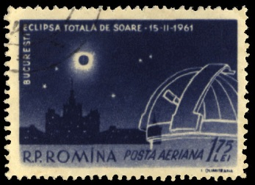

Romania #C107, 1.75 lei

(Eclipse: Feb. 15, 1961)

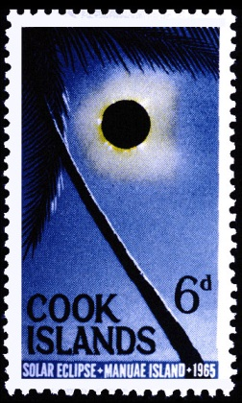

Cook Islands #159

(Eclipse: May 30, 1965)

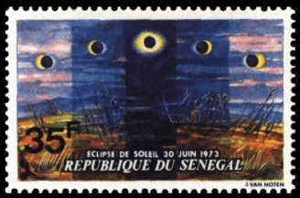

Senegal #388, 35 franc  
 (Eclipse: June 30, 1973)

**Solar Eclipse: August 21, 2017**

Thales showed his students that philosophers can be rich by cornering   
the olive-press market when predicting   
the solar eclipse of May 28, 585 B.C.

Exactly 2504 years later the eclipse   
of May 29, 1919 confirmed Einstein’s

Theory of Relativity that starlight   
would be bent by the Sun’s gravity.

Dante cites “eclipse” five times

in his *Paradiso*, on someone squinting   
at the eclipsed sun losing his sight and

he too blinded by blazing celestial light.

Three of the *Gospels* cite darkening   
of the Sun at Crucifixion from noon   
to three, but scholars say solar eclipses   
last at most seven minutes 31 seconds.

The solar eclipse of June 8, 1918 crossed   
from Washington State to Florida, similar   
to the ribbon pathway rolling across

the nation from Pacific to the Atlantic.

Annie Dillard compares a partial to   
a total eclipse as kissing a man to   
marrying him or flying in a plane   
to jumping out of one— that’s why

536,000 cars entered Wyoming   
a few days before the total eclipse

to drink in this nature’s splendor—  
Birds flew hither & thither, temperature

plummeted, Native Americans drummed   
louder and faster, chanting to bring back   
the sun eaten by some dragon or demon,   
people were crying, sobbing, screaming.

But it’s just the Moon making love   
to the Sun, two celestial bodies from   
night & day coming together with  
all the stars out and us watching.

Peter Y. Chou

Mountain View, 9-1-2017

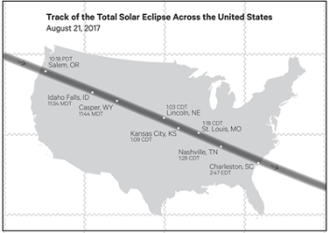

U.S. #5207 “Total Eclipse of the Sun”

Back of Sheet: Track of Eclipse across the U.S.

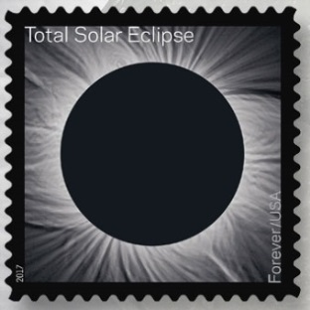

U.S. #5201. 49¢ Forever

(Eclipse: August 21, 2017)

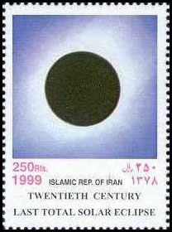

Iran #2772c, 250 rials  
 (Eclipse: Aug. 11, 1999)

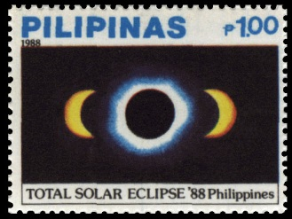

Philippines #1922, 1 peso   
 (Eclipse: March 18, 1988)

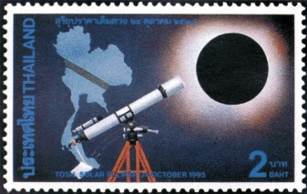

Thailand #1628, 2 baht

(Eclipse: Oct. 24, 1995)

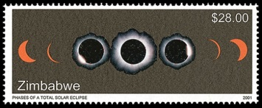

Zimbabwe #884, $28.00

(Eclipse: June 21, 2001)

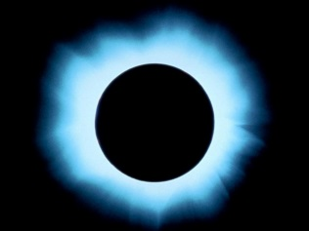

Sun’s Corona

during a total solar eclipse